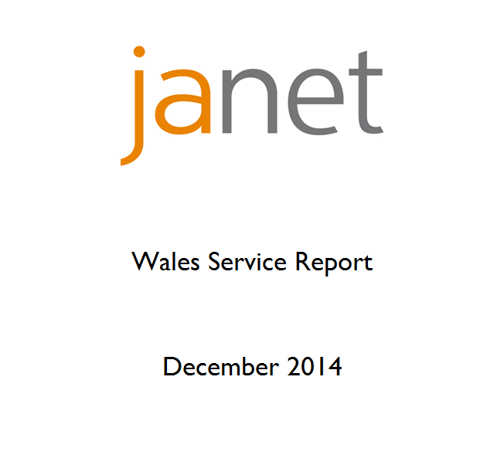

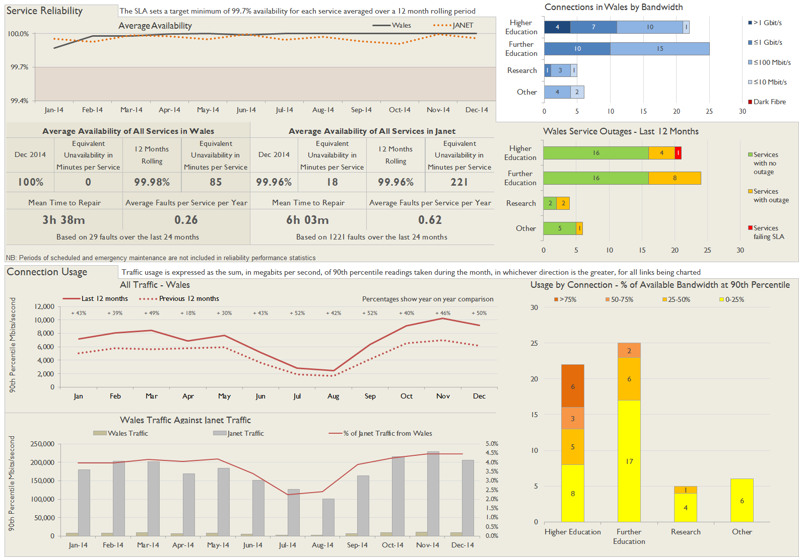

**Service Availability**

The SLA target sets a minimum of 99.7% availability for each customer, averaged over a 12 month rolling period

Periods of scheduled and emergency maintenance are discounted when calculating availability of services

Where an organisation retains connectivity during an outage period by means of a second connection, the outage is not counted against its availability figures

Monthly and annual availabilities falling below 99.7% are highlighted

| Service | Jan 14 | Feb 14 | Mar 14 | Apr 14 | May 14 | Jun 14 | Jul 14 | Aug 14 | Sep 14 | Oct 14 | Nov 14 | Dec 14 | 12 Month Rolling Availability |
| --- | --- | --- | --- | --- | --- | --- | --- | --- | --- | --- | --- | --- | --- |
| Aberystwyth University | 100% | 100% | 100% | 100% | 100% | 100% | 100% | 100% | 100% | 100% | 100% | 100% | 100% |
| Aberystwyth University | 100% | 100% | 100% | 100% | 100% | 100% | 100% | 100% | 100% | 100% | 100% | 100% | 100% |
| Bangor University | 100% | 100% | **99.60%** | 100% | 100% | 100% | 100% | 100% | 100% | 100% | 100% | 100% | **99.97%** |
| Bridgend College | 100% | 100% | 100% | 100% | 100% | 100% | 100% | 100% | 100% | 100% | 100% | 100% | 100% |
| Cardiff Metropolitan University | 100% | 100% | 100% | 100% | 100% | 100% | 100% | 100% | 100% | 100% | 100% | 100% | 100% |
| Cardiff Metropolitan University | 100% | 100% | 100% | 100% | 100% | 100% | 100% | 100% | 100% | 100% | 100% | 100% | 100% |
| Cardiff University | 100% | 100% | 100% | 100% | 100% | 100% | 100% | 100% | 100% | 100% | 100% | 100% | 100% |
| Cardiff University | 100% | 100% | 100% | 100% | 100% | 100% | 100% | 100% | 100% | 100% | 100% | 100% | 100% |
| Coleg Cambria | **99.93%** | 100% | 100% | 100% | 100% | 100% | 100% | 100% | 100% | 100% | 100% | 100% | **>99.99%** |
| Coleg Cambria | **99.93%** | 100% | 100% | 100% | 100% | 100% | 100% | 100% | 100% | 100% | 100% | 100% | **>99.99%** |
| Coleg Cambria | **99.93%** | 100% | 100% | 100% | 100% | 100% | 100% | 100% | 100% | 100% | 100% | 100% | **>99.99%** |
| Coleg Cambria | **99.93%** | 100% | 100% | 100% | 100% | 100% | 100% | 100% | 100% | 100% | 100% | 100% | **>99.99%** |
| Coleg Ceredigion | 100% | 100% | 100% | 100% | 100% | 100% | 100% | 100% | 100% | 100% | 100% | 100% | 100% |
| Coleg Ceredigion | 100% | 100% | 100% | 100% | 100% | 100% | 100% | 100% | 100% | 100% | 100% | 100% | 100% |
| Coleg Elidyr | 100% | 100% | 100% | 100% | **99.98%** | 100% | 100% | 100% | 100% | 100% | 100% | 100% | **>99.99%** |
| Coleg Gwent | 100% | 100% | 100% | 100% | 100% | 100% | 100% | 100% | 100% | 100% | 100% | 100% | 100% |
| Coleg Gwent | 100% | 100% | 100% | 100% | 100% | 100% | 100% | 100% | 100% | 100% | 100% | 100% | 100% |
| Coleg Harlech Workers' Educational Association | **99.28%** | 100% | 100% | 100% | 100% | 100% | 100% | 100% | 100% | 100% | 100% | 100% | **99.94%** |
| Coleg Sir Gar | 100% | 100% | 100% | 100% | 100% | 100% | 100% | 100% | 100% | 100% | 100% | 100% | 100% |
| Coleg Y Cymoedd | 100% | 100% | 100% | 100% | 100% | 100% | 100% | 100% | 100% | 100% | 100% | 100% | 100% |
| Coleg Y Cymoedd | 100% | 100% | 100% | 100% | 100% | 100% | 100% | 100% | 100% | 100% | 100% | 100% | 100% |
| Glyndwr University | **99.93%** | 100% | 100% | 100% | 100% | 100% | 100% | 100% | 100% | 100% | 100% | 100% | **>99.99%** |
| Gower College Swansea | 100% | 100% | 100% | 100% | 100% | 100% | 100% | 100% | 100% | 100% | 100% | 100% | 100% |
| Gower College Swansea | 100% | 100% | 100% | 100% | 100% | 100% | 100% | 100% | 100% | 100% | 100% | 100% | 100% |
| Grwp Llandrillo-Menai | 100% | 100% | **99.60%** | 100% | 100% | 100% | 100% | 100% | 100% | 100% | 100% | 100% | **99.97%** |
| Grwp Llandrillo-Menai | 100% | 100% | 100% | 100% | 100% | 100% | 100% | 100% | 100% | 100% | 100% | 100% | 100% |
| High Performance Computing Wales | 100% | **99.60%** | 100% | 100% | 100% | 100% | 100% | 100% | 100% | 100% | 100% | 100% | **99.97%** |
| Higher Education Funding Council for Wales | 100% | 100% | 100% | 100% | 100% | 100% | 100% | 100% | 100% | 100% | 100% | 100% | 100% |
| Medical Research Council | 100% | 100% | 100% | 100% | 100% | 100% | 100% | 100% | 100% | 100% | 100% | 100% | 100% |
| Merthyr Tydfil College Limited | 100% | 100% | 100% | 100% | 100% | 100% | 100% | 100% | 100% | 100% | 100% | 100% | 100% |
| Mudiad Meithrin | 100% | 100% | 100% | 100% | 100% | 100% | 100% | 100% | 100% | 100% | 100% | 100% | 100% |
| National Institute of Adult Continuing Education | 100% | 100% | 100% | 100% | 100% | 100% | 100% | 100% | 100% | 100% | 100% | 100% | 100% |
| Natural Environment Research Council | 100% | 100% | 100% | **99.95%** | 100% | **99.19%** | 100% | 100% | 100% | 100% | 100% | 100% | **99.93%** |
| Natural Environment Research Council | 100% | 100% | **99.60%** | 100% | 100% | 100% | 100% | 100% | 100% | 100% | 100% | 100% | **99.97%** |
| Natural Environment Research Council | 100% | 100% | 100% | 100% | 100% | 100% | 100% | 100% | 100% | 100% | 100% | 100% | 100% |
| Neath Port Talbot College | 100% | 100% | 100% | 100% | 100% | 100% | 100% | 100% | 100% | 100% | 100% | 100% | 100% |
| Neath Port Talbot College | **99.66%** | 100% | 100% | **99.85%** | 100% | 100% | 100% | 100% | 100% | 100% | 100% | 100% | **99.96%** |
| Pembrokeshire College | 100% | 100% | 100% | 100% | 100% | 100% | 100% | 100% | 100% | 100% | 100% | 100% | 100% |
| Royal Mencap Society | **99.93%** | 100% | 100% | 100% | **99.95%** | 100% | 100% | 100% | 100% | 100% | 100% | 100% | **>99.99%** |
| Royal Welsh College of Music and Drama | 100% | 100% | 100% | 100% | 100% | 100% | 100% | 100% | 100% | 100% | 100% | 100% | 100% |
| St David's Catholic College | 100% | 100% | 100% | 100% | 100% | 100% | 100% | 100% | 100% | 100% | 100% | 100% | 100% |
| Swansea University | 100% | 100% | 100% | 100% | 100% | 100% | 100% | 100% | 100% | 100% | 100% | 100% | 100% |
| Swansea University | 100% | 100% | 100% | 100% | 100% | 100% | 100% | 100% | 100% | 100% | 100% | 100% | 100% |
| The Cardiff and Vale College | 100% | 100% | 100% | 100% | 100% | 100% | 100% | 100% | 100% | 100% | 100% | 100% | 100% |
| The Cardiff and Vale College | 100% | **99.60%** | 100% | 100% | 100% | 100% | 100% | 100% | 100% | 100% | 100% | 100% | **99.97%** |
| University of Glamorgan | 100% | 100% | 100% | 100% | 100% | 100% | 100% | 100% | 100% | 100% | 100% | 100% | 100% |
| University of Glamorgan | **0.00%** | **0.00%** | **0.00%** | **0.00%** | **0.00%** | **0.00%** | **0.00%** | **0.00%** | 100% | 100% | 100% | 100% | <12 Months |
| University of Glamorgan | 100% | 100% | 100% | 100% | 100% | 100% | 100% | 100% | 100% | 100% | 100% | 100% | 100% |
| University of Wales | 100% | **99.60%** | 100% | 100% | 100% | 100% | 100% | 100% | 100% | 100% | 100% | 100% | **99.97%** |
| University of Wales Trinity Saint David | 100% | 100% | 100% | 100% | 100% | 100% | 100% | 100% | 100% | 100% | 100% | 100% | 100% |
| University of Wales Trinity Saint David | 100% | 100% | 100% | 100% | 100% | 100% | 100% | 100% | 100% | 100% | 100% | 100% | 100% |
| University of Wales Trinity Saint David | 100% | 100% | 100% | 100% | 100% | 100% | 100% | 100% | 100% | 100% | 100% | 100% | 100% |
| University of Wales, Newport | 100% | 100% | 100% | 100% | 100% | 100% | 100% | 100% | 100% | 100% | 100% | 100% | 100% |
| Workers' Educational Association Wales | 100% | 100% | 100% | 100% | 100% | 100% | 100% | 100% | 100% | 100% | 100% | 100% | 100% |
| Y Coleg Cymraeg Cenedlaethol | 100% | 100% | 100% | 100% | 100% | 100% | 100% | 100% | 100% | 100% | 100% | 100% | 100% |
| Y Coleg Cymraeg Cenedlaethol | **94.22%** | 100% | 100% | 100% | 100% | 100% | 100% | 100% | 100% | 100% | 100% | 100% | **99.52%** |

**Connection outages this month**

Maintenance outages are included in this table - only unscheduled maintenance is counted against availability.

| Connection | Start Date and Time | End Date and Time | Parking hh:mm | Duration hh:mm | Fault Type | Description |
| --- | --- | --- | --- | --- | --- | --- |
| Aberystwyth University, Llandinam Building | 09/12/2014 08:28 | 09/12/2014 08:57 | 00:00 | 00:29 | Customer Maintenance | Customer upgraded router |
| University of Wales, Newport | 19/12/2014 23:31 | 20/12/2014 09:57 | 00:00 | 10:26 | Customer Equipment | Local UPS failure |
| Higher Education Funding Council for Wales | 30/12/2014 15:07 | 30/12/2014 15:39 | 00:00 | 00:32 | Unknown | Unknown |
|  |  |  |  |  |  |  |