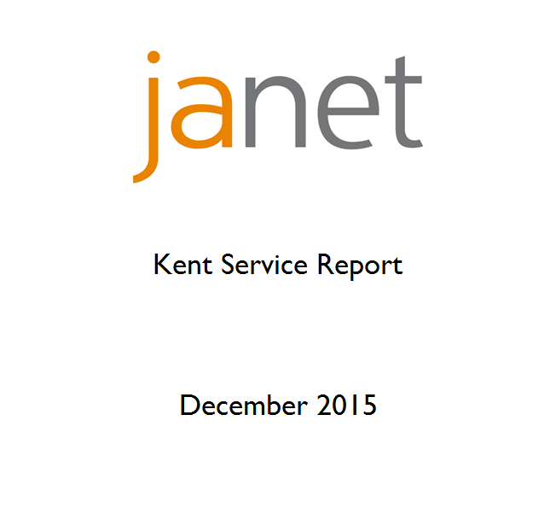

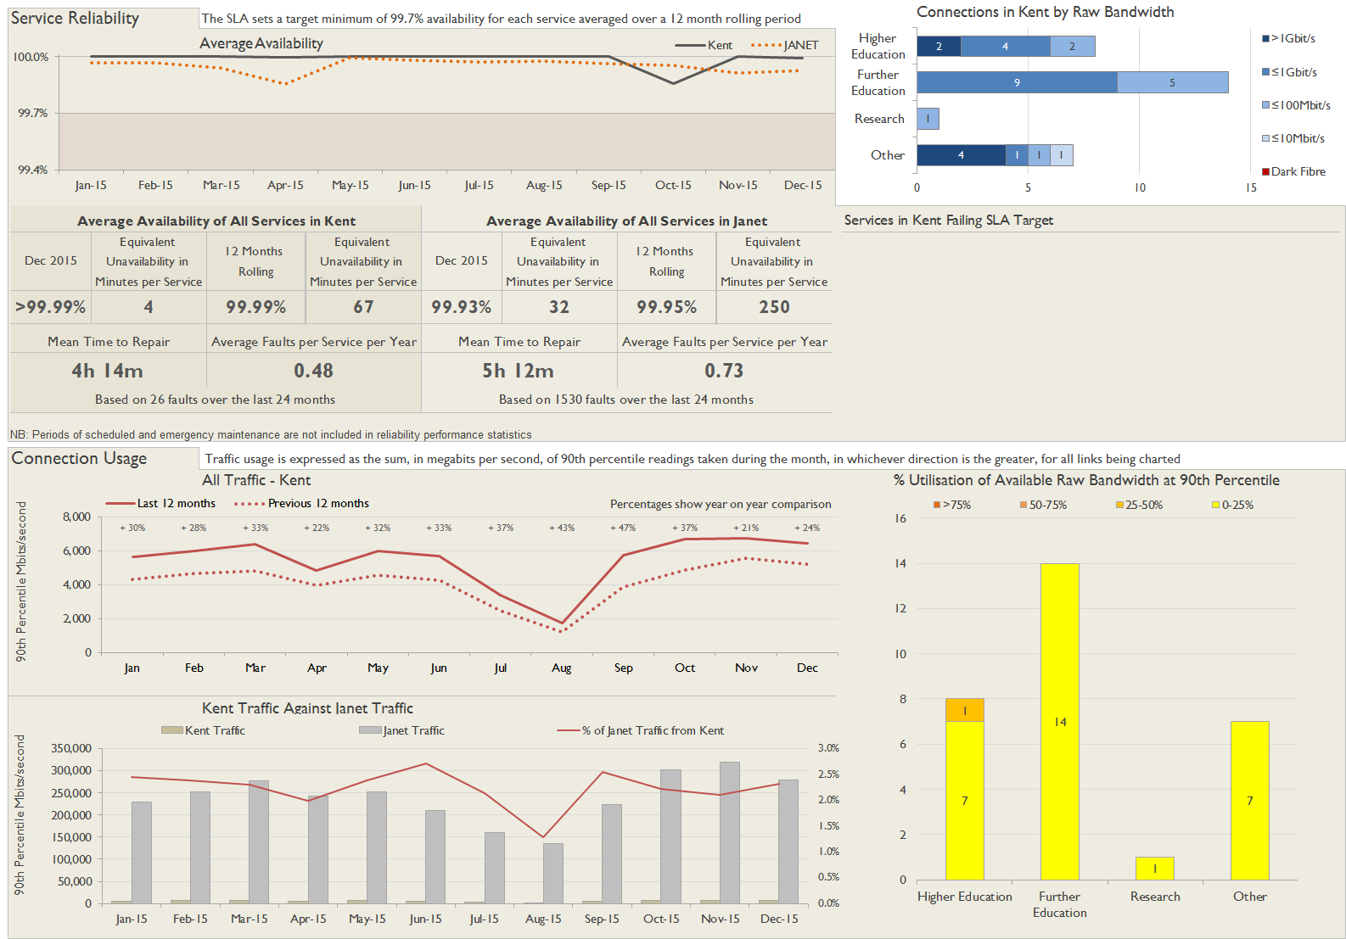

**Service Availability**

The SLA target sets a minimum of 99.7% availability for each customer, averaged over a 12 month rolling period

Periods of scheduled and emergency maintenance are discounted when calculating availability of services

Monthly and annual availabilities falling below 99.7% are highlighted

* Service has resilience - where an organisation retains connectivity during an outage period by means of a second connection, the outage is not counted against its availability figures

| Service | Jan 15 | Feb 15 | Mar 15 | Apr 15 | May 15 | Jun 15 | Jul 15 | Aug 15 | Sep 15 | Oct 15 | Nov 15 | Dec 15 | 12 Month Rolling Availability |
| --- | --- | --- | --- | --- | --- | --- | --- | --- | --- | --- | --- | --- | --- |
| Canterbury Christ Church University, Broadstairs Campus | 100% | 100% | 100% | **99.97%** | 100% | 100% | 100% | 100% | 100% | 100% | 100% | **99.78%** | **99.98%** |
| Canterbury Christ Church University, Canterbury Campus | 100% | 100% | 100% | 100% | 100% | 100% | 100% | 100% | 100% | 100% | 100% | 100% | 100% |
| Canterbury Christ Church University, Tunbridge Wells | 100% | 100% | 100% | 100% | 100% | 100% | 100% | 100% | 100% | 100% | 100% | 100% | 100% |
| Canterbury College, Cantebury Campus | 100% | 100% | 100% | 100% | 100% | 100% | 100% | 100% | 100% | 100% | 100% | 100% | 100% |
| Canterbury College, Swale Campus | 100% | 100% | 100% | 100% | 100% | 100% | 100% | 100% | 100% | 100% | 100% | 100% | 100% |
| East Kent College, Broadstairs Campus | 100% | 100% | 100% | 100% | 100% | 100% | 100% | 100% | 100% | 100% | 100% | 100% | 100% |
| East Kent College, Dover Campus | 100% | 100% | 100% | 100% | 100% | 100% | 100% | 100% | 100% | 100% | 100% | 100% | 100% |
| East Kent College, Folkestone Campus | 100% | 100% | 100% | **99.97%** | 100% | 100% | 100% | 100% | 100% | 100% | 100% | 100% | **>99.99%** |
| East Malling Research | 100% | 100% | 100% | 100% | 100% | 100% | 100% | 100% | 100% | 100% | 100% | 100% | 100% |
| Hadlow College, Canterbury Campus | 100% | 100% | 100% | 100% | 100% | 100% | 100% | 100% | 100% | **96.43%** | 100% | 100% | **99.70%** |
| Hadlow College, Greenwich Campus | 100% | 100% | 100% | 100% | 100% | 100% | 100% | 100% | 100% | 100% | 100% | 100% | 100% |
| Hadlow College, Hadlow Campus | 100% | 100% | 100% | 100% | 100% | 100% | 100% | 100% | 100% | 100% | 100% | 100% | 100% |
| Hadlow College, Mottingham Campus | 100% | 100% | 100% | 100% | 100% | 100% | 100% | 100% | 100% | 100% | 100% | 100% | 100% |
| Hilderstone College | 100% | 100% | 100% | **99.97%** | 100% | 100% | 100% | 100% | 100% | **99.94%** | 100% | 100% | **>99.99%** |
| ifs University College, Kent Campus | 100% | 100% | 100% | 100% | 100% | 100% | 100% | 100% | 100% | **99.80%** | 100% | 100% | **99.98%** |
| Kent County Council * | 100% | 100% | 100% | 100% | 100% | 100% | 100% | 100% | 100% | 100% | 100% | 100% | 100% |
| Medway Council | 100% | 100% | 100% | 100% | 100% | 100% | 100% | 100% | 100% | 100% | 100% | 100% | 100% |
| MidKent College | 100% | 100% | 100% | 100% | 100% | 100% | 100% | 100% | 100% | 100% | 100% | 100% | 100% |
| North Kent College | 100% | 100% | 100% | 100% | 100% | 100% | 100% | 100% | 100% | 100% | 100% | 100% | 100% |
| University for the Creative Arts, Canterbury Campus | 100% | 100% | 100% | 100% | 100% | 100% | 100% | 100% | 100% | 100% | 100% | 100% | 100% |
| University for the Creative Arts, Rochester Campus | 100% | 100% | 100% | 100% | 100% | 100% | 100% | 100% | 100% | 100% | 100% | 100% | 100% |
| University of Greenwich, The Universities at Medway | 100% | 100% | 100% | 100% | 100% | 100% | 100% | 100% | 100% | 100% | 100% | 100% | 100% |
| University of Kent, Canterbury Campus | 100% | 100% | 100% | 100% | 100% | 100% | 100% | 100% | 100% | 100% | 100% | 100% | 100% |
| University of Kent, Tonbridge Campus | 100% | 100% | 100% | 100% | 100% | 100% | 100% | 100% | 100% | 100% | 100% | 100% | 100% |
| West Kent and Ashford College, Ashford Campus | 100% | 100% | 100% | 100% | 100% | 100% | 100% | 100% | 100% | 100% | 100% | 100% | 100% |
| West Kent and Ashford College, Tonbridge Campus | 100% | 100% | 100% | 100% | 100% | 100% | 100% | 100% | 100% | 100% | 100% | 100% | 100% |
| Workers' Educational Association, Southern | 100% | 100% | 100% | 100% | 100% | 100% | 100% | 100% | 100% | 100% | 100% | 100% | 100% |

**Connection outages for current month**

Maintenance outages are included in this table - only unscheduled maintenance is counted against availability.

Some of the outages reported below are on circuits which are not connected through the selected region - they appear in the table because they are part of a service whose primary connection does belong to this region.

| Connection | Start Date and Time | End Date and Time | Parking hh:mm | Duration hh:mm | Fault Type | Description |
| --- | --- | --- | --- | --- | --- | --- |
| Canterbury Christ Church University, Broadstairs Campus | 15/12/2015 07:02 | 15/12/2015 08:41 | 00:00 | 01:39 | Regional Maintenance | RNO third party unscheduled maintenance |
| University for the Creative Arts, Canterbury Campus | 15/12/2015 17:29 | 15/12/2015 17:45 | 00:00 | 00:16 | Customer Maintenance | Unscheduled maintenance |
| Hadlow College, Greenwich Campus | 09/12/2015 01:02 | 09/12/2015 02:05 | 00:00 | 01:03 | Unknown | Unknown |

**Link Utilisation of Raw Bandwidth**

The table shows utilisation at the 90th percentile, i.e. for 90% of the samples within the period the traffic was at or below the level shown and for 10% of the samples traffic was above the level shown. The figure therefore gives a reasonable indication of the loading of the connection during the busiest periods. The measurements are shown as a percentage of the available raw bandwidth, and only the highest of the to/from readings for the month is used.

Some of the connections reported below are not connected through the selected region - they appear in the table because they are part of a service whose primary connection does belong to this region.

| Connection | Current Bandwidth | Jan-15 | Feb-15 | Mar-15 | Apr-15 | May-15 | Jun-15 | Jul-15 | Aug-15 | Sep-15 | Oct-15 | Nov-15 | Dec-15 |
| --- | --- | --- | --- | --- | --- | --- | --- | --- | --- | --- | --- | --- | --- |
| Canterbury Christ Church University, Broadstairs Campus | 1Gbit/s | 3% | 3% | 4% | 2% | 2% | 1% | 1% | 1% | 2% | 3% | 3% | 3% |
| Canterbury Christ Church University, Canterbury Campus | 1Gbit/s | 23% | 26% | 26% | 23% | 19% | 15% | 15% | 12% | 21% | 32% | 36% | 24% |
| Canterbury Christ Church University, Tunbridge Wells | 100Mbit/s | 5% | 5% | 5% | 4% | 4% | 4% | 4% | 2% | 5% | 5% | 6% | 4% |
| Canterbury College, Cantebury Campus | 1Gbit/s | 18% | 16% | 20% | 14% | 17% | 18% | 7% | 4% | 13% | 21% | 22% | 22% |
| Canterbury College, Swale Campus | 100Mbit/s | 8% | 7% | 8% | 4% | 7% | 8% | 2% | 1% | 7% | 10% | 15% | 11% |
| East Kent College, Broadstairs Campus | 1Gbit/s | 2% | 1% | 2% | 1% | 1% | 2% | <0.5% | <0.5% | 2% | 2% | 2% | 2% |
| East Kent College, Dover Campus | 1Gbit/s | 1% | 1% | 1% | 1% | 1% | 2% | <0.5% | <0.5% | 1% | 1% | 0% | 0% |
| East Kent College, Folkestone Campus | 1Gbit/s | 4% | 4% | 5% | 3% | 3% | 3% | 1% | 1% | 2% | 3% | 4% | 4% |
| East Malling Research | 100Mbit/s | 7% | 7% | 7% | 8% | 6% | 8% | 9% | 10% | 10% | 11% | 13% | 11% |
| Hadlow College, Canterbury Campus | 100Mbit/s | <0.5% | <0.5% | <0.5% | <0.5% | <0.5% | <0.5% | <0.5% | <0.5% | <0.5% | <0.5% | <0.5% | <0.5% |
| Hadlow College, Greenwich Campus | 100Mbit/s | 1% | 1% | 2% | 1% | 1% | 1% | 1% | 2% | 2% | 2% | 3% | 0% |
| Hadlow College, Hadlow Campus | 1Gbit/s | <0.5% | <0.5% | <0.5% | <0.5% | <0.5% | <0.5% | <0.5% | <0.5% | <0.5% | <0.5% | <0.5% | <0.5% |
| Hadlow College, Mottingham Campus | 100Mbit/s | <0.5% | <0.5% | <0.5% | <0.5% | <0.5% | <0.5% | <0.5% | <0.5% | <0.5% | <0.5% | <0.5% | <0.5% |
| Hilderstone College | 100Mbit/s | 1% | 1% | 1% | 1% | 1% | 1% | 1% | 1% | 1% | 1% | 1% | 1% |
| ifs University College, Kent Campus | 100Mbit/s | 6% | 8% | 9% | 9% | 10% | 8% | 9% | 8% | 8% | 10% | 10% | 8% |
| Kent County Council, Canterbury (1) | 10Gbit/s | 11% | 11% | 12% | 8% | 12% | 12% | 10% | 2% | 12% | 12% | 12% | 11% |
| Kent County Council, Canterbury (2) | 10Gbit/s | <0.5% | <0.5% | <0.5% | <0.5% | <0.5% | <0.5% | <0.5% | <0.5% | <0.5% | <0.5% | <0.5% | <0.5% |
| Kent County Council, Maidstone (1) | 10Gbit/s | 10% | 10% | 11% | 7% | 11% | 10% | 10% | 3% | 12% | 12% | 13% | 12% |
| Kent County Council, Maidstone (2) | 10Gbit/s | 1% | 1% | 1% | 1% | 1% | 1% | 1% | 1% | 1% | 1% | 1% | 1% |
| Medway Council | 1Gbit/s | 10% | 10% | 11% | 8% | 9% | 10% | 9% | 5% | 11% | 10% | 11% | 1% |
| MidKent College, Medway Campus | 1Gbit/s | 18% | 18% | 20% | 14% | 19% | 20% | 4% | 2% | 12% | 19% | <0.5% | <0.5% |
| North Kent College | 1Gbit/s | 14% | 14% | 17% | 10% | 14% | 13% | 3% | 2% | 11% | 16% | 14% | 8% |
| University for the Creative Arts, Canterbury Campus | 1Gbit/s | 0% | 0% | 0% | 0% | 0% | 0% | 0% | 0% | 0% | 0% | 0% | 0% |
| University for the Creative Arts, Rochester Campus | 1Gbit/s | 5% | 6% | 7% | 8% | 9% | 10% | 3% | 2% | 4% | 7% | 7% | <0.5% |
| University of Greenwich, The Universities at Medway | 2Gbit/s | 9% | 12% | 13% | 10% | 8% | 6% | 6% | 5% | 9% | 13% | 14% | 12% |
| University of Kent, Canterbury Campus | 8Gbit/s | 27% | 30% | 30% | 26% | 30% | 26% | 9% | 8% | 27% | 34% | 35% | 38% |
| University of Kent, Tonbridge Campus | 100Mbit/s | <0.5% | <0.5% | <0.5% | <0.5% | <0.5% | <0.5% | 1% | <0.5% | <0.5% | <0.5% | <0.5% | <0.5% |
| West Kent and Ashford College, Ashford Campus | 1Gbit/s | 1% | 1% | 2% | 1% | 2% | 2% | 1% | <0.5% | 1% | 1% | 1% | 1% |
| West Kent and Ashford College, Tonbridge Campus | 1Gbit/s | 7% | 6% | 8% | 3% | 7% | 7% | 1% | 1% | 3% | 5% | 2% | <0.5% |
| Workers' Educational Association, Southern | 10Mbit/s | 5% | 5% | 5% | 5% | 4% | 5% | 6% | 5% | 5% | 6% | 7% | 4% |