Implementing eduroam(UK) NAPTR requirements on Windows Server 2008 R2

This guide will help administrators at eduroam(UK) sites that use Microsoft DNS (on Windows Server 2008 R2 – previous versions do not support such queries!) to add the required NAPTR and SRV records to their zones for the required directing of international RadSec requests.

Thanks go to Tim Johnson and John Windle of Liverpool John Moores University for guidance and providing the screenshots.

1) In the 'DNS Manager' GUI, open the zone file for your domain (in this case ljmu.ac.uk).

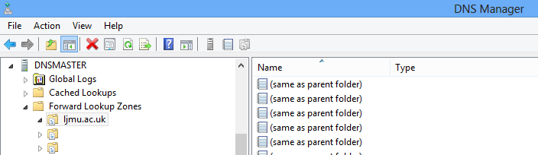

2) Right-click and choose "Other New Records"

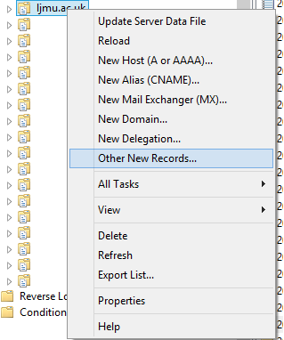

3) Scroll down and select the type as NAPTR:

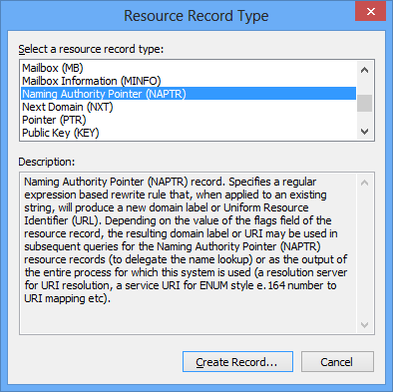

4) In the dialogue box, enter details in the format shown below (substituting the ljmu.ac.uk entry in the below screenshot for your own realm name). Ensure that the record name is left as the default "(same as parent folder)":
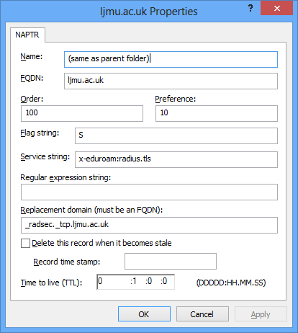

The created record will look similar to this:

5) Next, locate the "_tcp" folder below your zone file name:

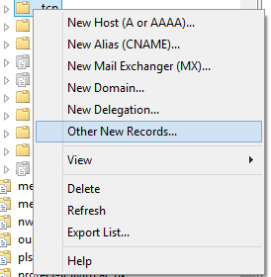

6) Right-click and choose "Other New Records"

7) Scroll down and select the type as SRV:

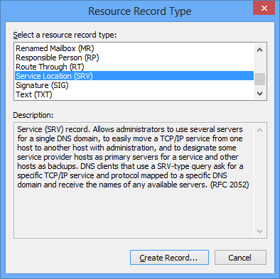

8) Complete the new record form as shown below using '_radsec' as the protocol name and 2083 as the port (substituting the references to ljmu.ac.uk for your own realm):

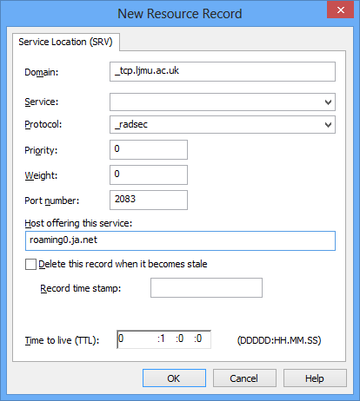

9) Repeat step 8 for roaming1.ja.net and roaming2.ja.net which will leave 3 SRV records in place:

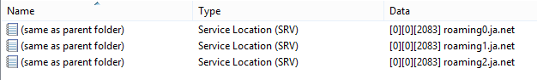

10) Test a successful NAPTR lookup using the tools at e.g. http://www.network-tools.com using their 'Advanced DNS Record Lookup' tool:

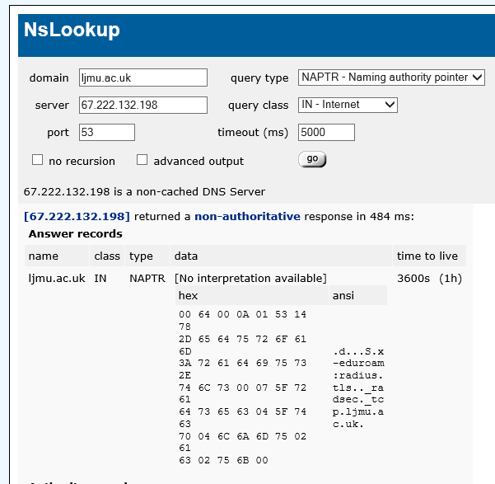

Dr. Alan Buxey
14/1/2013

