### APPENDIX 12/01

**ExECUTIVE SUMMARY FOR Lifesize TEAM 220™**

### Manufacturer: LifeSize

**Model: Team 220™**

**Software Version: 4.10.0**

Optional Features and

Modifications: None

**Date of Test: 5th – 9th March 2012**

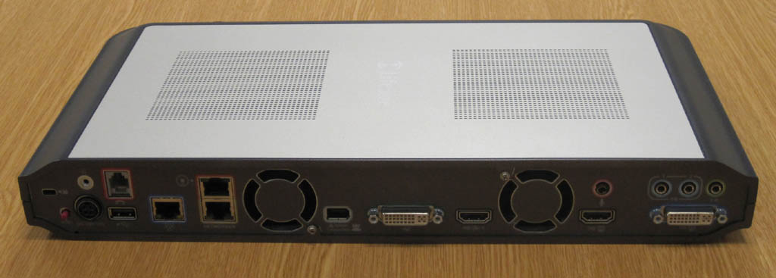

**Codec Rear View**

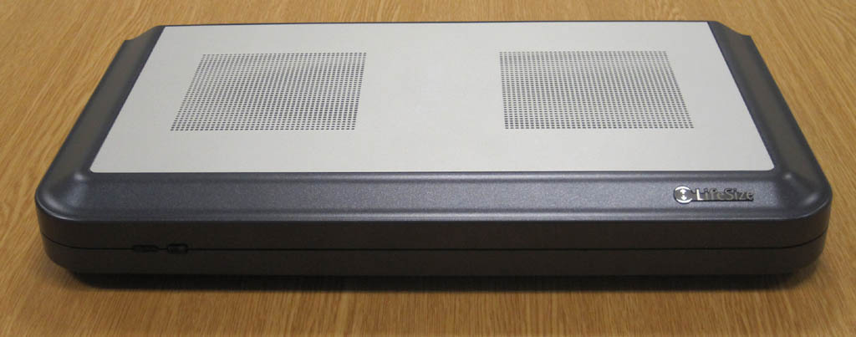

**Codec Front View**

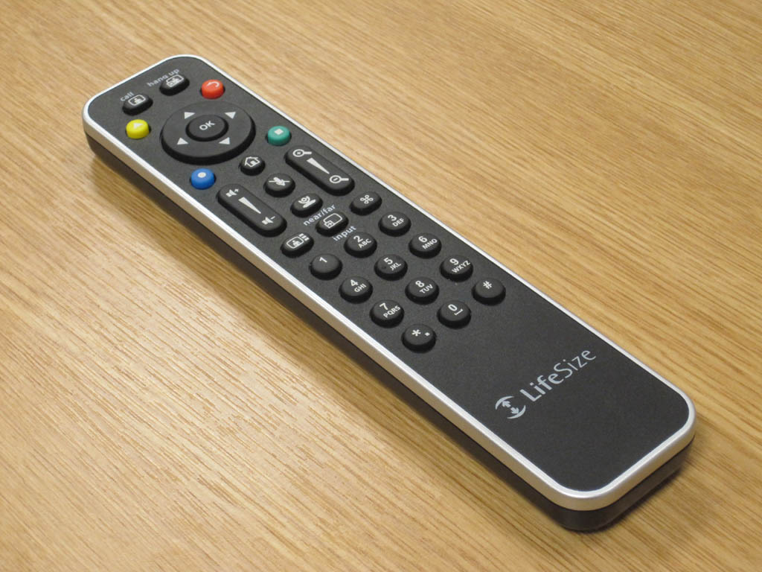

**Remote Control**

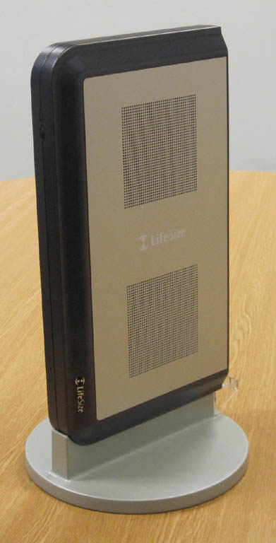

**CODEC on Stand**

**Codec Front View**

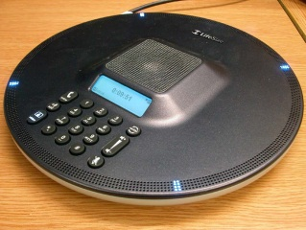

**LifeSize Phone™**

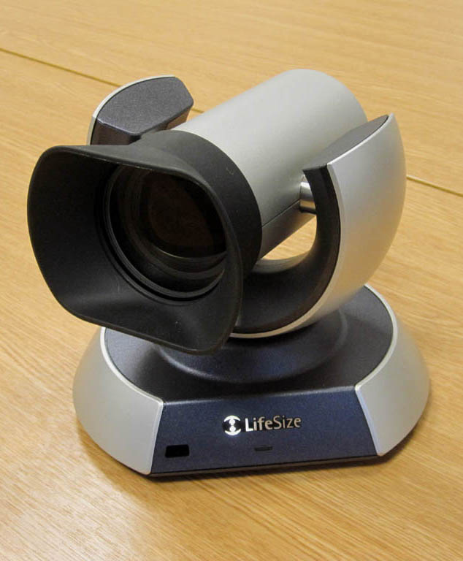

**10x HD Camera**

**EXECUTIVE SUMMARY**

The IP capable high definition Lifesize Team 220™ conferencing system is designed to be installed either in a small to medium sized conference room or as part of a Rollabout system.

The system includes a high definition (HD) Camera, microphone/s and infrared remote control. A four site continuous presence on-board Multipoint Conference Unit (MCU) is included as standard.

The system is available with 2 camera and 2 microphone options:

* CODEC, Camera 200, Dual MicPods
* CODEC, Camera 10x, Dual MicPods
* CODEC, Camera 200, LifeSize Phone™
* CODEC, Camera 10x, LifeSize Phone™

The 10x Camera has a 10x zoom lens and is more sensitive in low light conditions than the 200 with its 4x zoom.

# The systems supplied for evaluation included the 10x Cameras and the LifeSize Phone™ desk microphone/conference phones.

The system is capable of conferencing up to a maximum picture resolution of 1920x1080 pixels (1080p) at 30fps or 1280x720 pixels (720p) at 60fps with a maximum connection speed of 6 Mbit/s. Compatibility with other H.323 CODECS is achieved across a range of resolutions from CIF (352x288) to 1920x1080 pixels, the quality of the conference being dependent upon the capability of the remote CODEC and the speed of connection.

The default setting of 720p @ 60 frames per second was used for the majority of the evaluation.

Pros:

* The sensitivity of the Camera 10x is improved over earlier LifeSize models
* Dual monitor as standard
* On-board 4 site continuous presence MCU as standard
* Good compatibility with other CODECS
* May be used in permanent installations or as a Rollabout

Cons:

* Camera mechanical noise
* Cooling fan noise
* Restricted frame rate on Presentation channel

Feature Summary:

|  |  |
| --- | --- |
| Video standards | H.261, H.263, H.263+ and H.264 |
| Supported video resolutions | QSIF (176x120) QCIF (176x144) SIF (352x240) CIF (352x288) 4SIF (704x480) 4CIF (704x576) 720p (1280x720) at 60 fps  1080p (1920x1080) at 30fps |
| Communications | H.323 128Kbps - 6Mbps  H.320 via optional LifeSize Networker |
| Audio standards | G.711, G.722, G.722.1, G.728, G.729, Siren 14 and MPEG4 AAC-LC 16KHz audio coding |
| Camera | 4x or 10x Optical zoom camera, PTZ function, 1080p native resolution, 10 camera presents, far end camera control, second 720p only camera may be added |
| Video inputs | PTZ Camera input (1080p), second camera input (720p), VGA/DVI Input |
| Video outputs | Dual monitor support  VGA/DVI video output, HDMI output |
| Audio inputs | Lifesize Phone™, MicPod microphone, 2 x stereo line in, analogue telephone line. |
| Audio outputs | HDMI audio output, 3.5mm mini jack audio output |
| VC Auxiliary features | H.239 second video channel up to 720p resolution in point to point and Multisite calls. Only the VGA input may be shared on the H.239 channel.  Four site internal H.323 MCU supporting Continuous Presence only.  Lifesize Phone™ desk microphone/speakerphone |
| Encryption | AES Encryption |